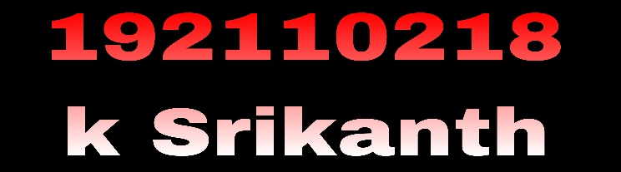

**QUESTION :**

1.Develop a system using UML for implementing E-Ticketing System. This is to be used by the passenger for reserving the tickets for their travel. This E-ticketing is organized by the central system. The information is provided by the railway reservation system.

**AIM : To develop the E - Ticketing system using umbrello tool and to implement using visual basic.**

**USE CASE DIAGRAM :**

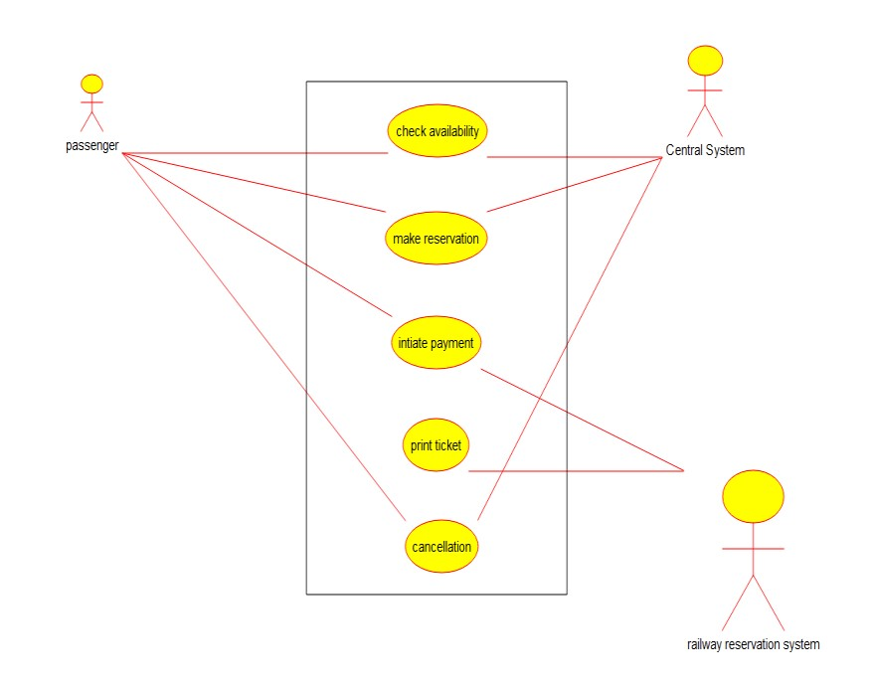

Bhavana sri

**CLASS DIAGRAM :**

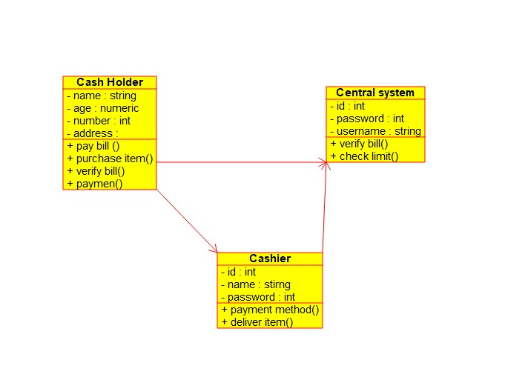

Bhavana sri

**ACTIVITY DIAGRAM :**

Bhavana sri

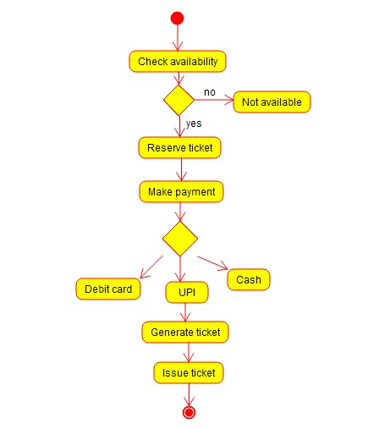

**RESULT : Thus the UML diagram for e- ticketing system has been implemented by using umbrello software.**

QUESTION:

2.Develop a system using UML for implementing Credit Card Processing System. In this system, the cardholder can purchase items and pays the bill with the aid of a credit card. The cashier should accept the card and proceed with the transaction using the central system. The bill is to be verified and the items are delivered to the cardholder based on it.

**AIM : To develop the UML diagram for implementing credit card processing system by using umbrello software.**

**USE CASE DIAGRAM :**

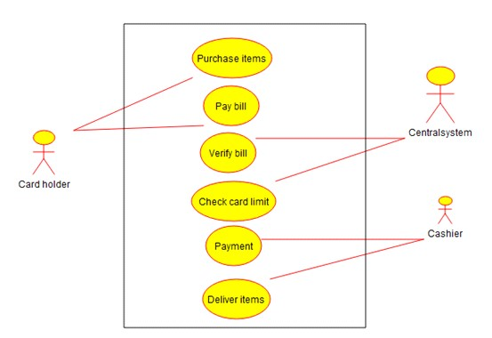

Bhavana sri

**CLASS DIAGRAM :**

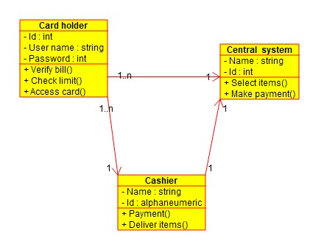

Bhavana sri

**ACTIVITY DIAGRAM :**

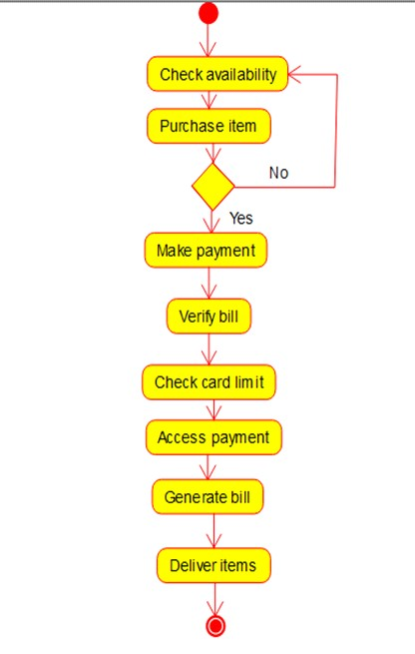

Bhavana sri

**RESULT : Thus the UML diagram for implementing credit card processing system has been implemented by using umbrello software .**

**QUESTION:**

3.Develop a system using UML for Software Personnel Management System. It should be used to process the details of a person who works in a software company. The details are to be stored in the central management system for cross-checking the person’s details.

**AIM : To develop the UML diagram for software personnal management system using umbrello software.**

**USE CASE DIAGRAM :**

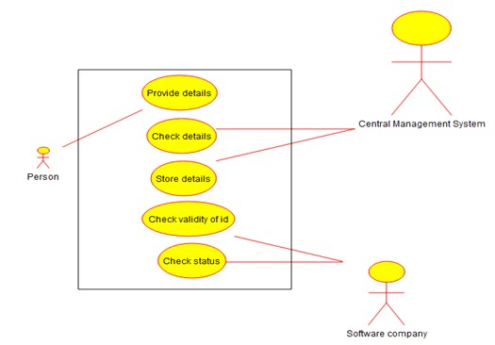

# CLASS DIAGRAM : bhavana sri

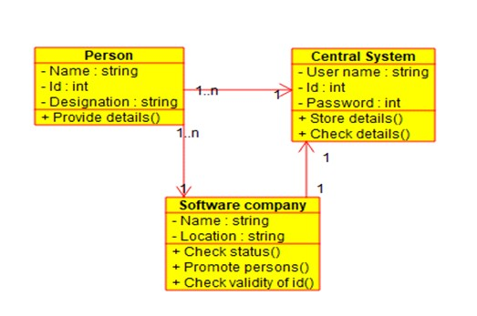

**ACTIVITY DIAGRAM :**

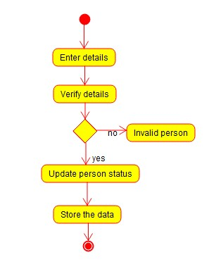

Bhavana sri

**RESULT : Thus the UML diagram for the software personnal management system has been implemented by using umbrello software.**

QUESTION:

4.Develop a system using UML for E-Book Management System. It should be designed to manage the books that were read through the internet. That should consist of the details of the e-book that were read by the user online. It will be controlled by the central system. This system should act as a backup of all details together.

**AIM : To draw the UML diagram for e-book management system using umbrello software.**

**USE CASE DIAGRAM :**

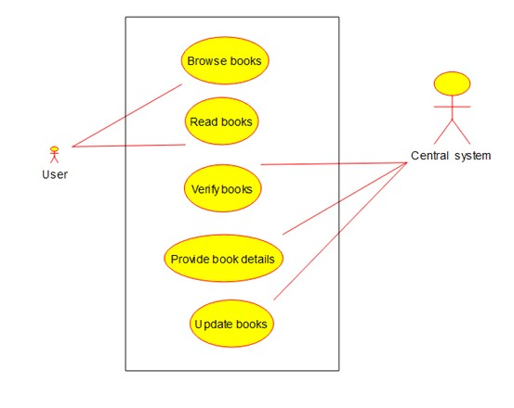

Bhavana sri

**CLASS DIAGRAM :**

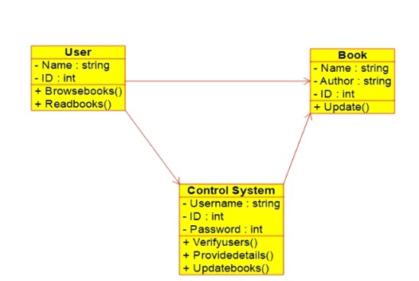

Bhavana sri

**ACTIVITY DIAGRAM :**

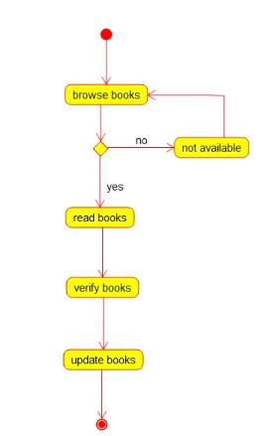

Bhavana sri

**RESULT: Thus the UML diagram for e-book management system has been implemented by using umbrello software.**